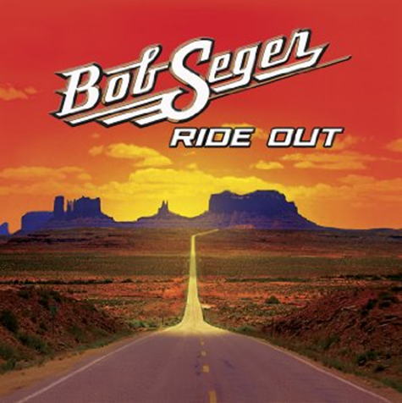
Turn the Page (Bob Seeger)

Em7 Em
On a long and lonely highway, east of Omaha,
D/F#
You can listen to the engine, moanin' out as one long song,
Asus2 Am Asus2 Em
You can think about the woman, or the girl you knew the night before.
Em
And your thoughts will soon be wandering, the way they always do,
D/F#
When you're riding sixteen hours and there's nothing much to do,
Asus2 Am Asus2 Em
You don't feel much like ridin', you just wish the trip was through.

D/F# Em
But here I am, on the road again,
D/F# Em
Here I am, up on stage,
D/F# Asus2 Am
Here I go, playing the star again,
C/G D/F# Em
There I go, turn the page.

Em
You walk into a restaurant, strung out from the road,
D/F#
And you feel the eyes upon you, as you're shaking off the cold,
Asus2 Am Asus2 Em
You pretend it doesn't bother you, but you just want to explode.
Em
Sometimes you hear 'em talkin', other times you can't,
D/F#
All the same old clichés, is that a woman or a man,
Asus2 Am Asus2 Em
And you always seem outnumbered, so you dare not make a stand.

Em
Out there in the spotlight, you're a million miles away,
D/F#
Every ounce of energy, you try to give away,
Asus2 Am Asus2 Em
And the sweat pours from your body, like the music that you play.
Em
Later on that evening, as you lie awake in bed,
D/F# Dsus2
Echoes of the amplifiers, ringin' in your head,
Asus2 Am Asus2 Em
And you smoke the day's last cigarette, remembering what she said.

