**QUESTIONS (Manfred Mann) KAPO 4 open E**

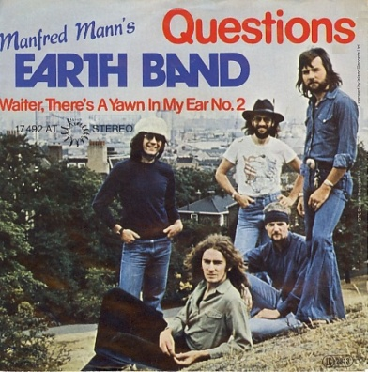

***C Am Dm G C***

***C Am Dm/F***

**In a dream, it would seem,**

***G C Fmaj G***

**I went to those who close, the open door.**

***C Am Dm/F G C***

**And turning the key, I sat and spoke to those inside of me.**

***Fmaj Dm***

**They answered my questions with questions,**

***Em/G FmajG***

**and they pointed me into the night.**

***G***

**Where the moon was a star-painted dancer,**

***C***

**and the world was just a spectrum of light.**

***Fmaj Dm***

**They reached to my center of reason,**

***Em F***

**and pulled on the touchstone that's there.**

***G***

**The shock of that light had me reeling,**

***C***

**and I fell into the depths of despair.**

***Repeat Verse: whistle***

***C Am Dm/F Gsus4 G C***

**Turning the key, I sat and spoke to those inside of me.**

***FmajF Dm***

**They answered my questions with questions,**

***Em F***

**and set me to stand on the brink.**

***Gsus4 G***

**Where the sun and the moon were as brothers,**

***C***

**and all that was left was to think.**

***FmajG Dm***

**They answered my questions with questions,**

***Em F***

**and pointed me into the night.**

***Gsus4 G***

**The power that bore me had left me alone,**

***C***

**to figure out which way was right.**