**I´M ON FIRE (Bruce Springsteen) CAPO IV open E - E**

**Intro:  *C (G) Am 2x***

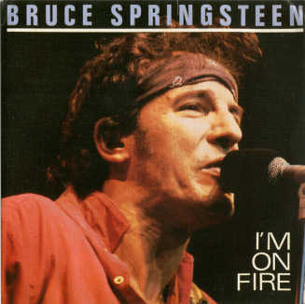

***C***

**Hey little girl is your daddy home,**

***Fmaj***

**did he go away and leave you all alone, hm hm**

***Am FmajF G add4 C***

**I got a bad desire, Ohhhhhhhhh, I'm on fire.**

***C***

**Tell me now baby is he good to you,**

***Fmaj***

**can he do to you the things that I do, oh no.**

***Am FmajF G C***

**I can take you higher, Ohhhhhhhhhh, I'm on fire.**

**Bridge: *Am add4 C 2x***

***Fmaj***

**Sometimes it's like someone took a knife baby edgy and dull and cut a**

***C Am***

**six-inch valley through the middle of my soul.**

***C***

**At night I wake up with the sheets soaking wet and a**

***Fmaj***

**freight train running through the middle of my head, only you,**

***Am FmajF G C***

**can cool my desire, Ohhhhhhhhh, I'm on fire.**

***FmajF G C***

**Ohhhhhhhhh, I'm on fire.**

***FmajF G C***

**Ohhhhhhhhh, I'm on fire.**

***Am C Am C***

**Uh uh, uh-uh, uh uh, Uh uh, uh-uh, uh uh,**