**FIRE (Bruce Springsteen) Open D TUNING**

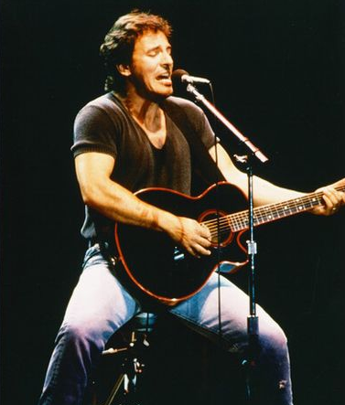 ***G***

**I´m driving in my car, I turn on the radio,**

***Am G***

**I´m pulling you close, you just say no.**

***Am Em***

**You say you don´t like it, but girl I know youre a liar**

***C D G***

**`cause when we kiss, oh oh, Fire.**

***G***

**Late at night, I´m takin you home,**

***Am G***

**I say I wanna stay, you say you wanna be alone.**

***Am Em***

**You say you don’t love me, girl you can´t hide your desire,**

***C D G***

**`cause when we kiss, oh oh, Fire!**

***C G***

**You had a hold on me, right from the start,**

***D G***

**A grip so tight I couldn't tear it apart,**

***C G***

**My nerves all jumpin actin like a fool,**

***A7 D7 /C /B***

**Well your kisses they burn but your heart stays cool**

**G**

**Romeo and Juliet, samson and Delilah,**

***Am G***

**Baby you can bet, their love they didn´t deny.**

***Am Em***

**Your words say split, but your words they lie,**

***C D G***

**`cause when we kiss, oh oh, Fire!**