**COUNTRY ROADS** (KAPO 4 open E)

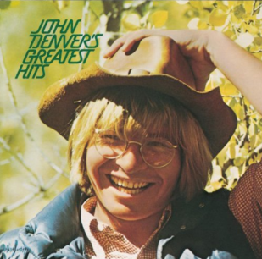

*C Am G FmajG C*

Almost heaven; West Virginia, blue ridge mountains, Shenandoah River.

*C Am G FmajG C*

Life is old here, older than the trees, younger than the mountains, blowin like a breeze.

*C G Am FmajG*

Country Roads, take me home, to a place, where I belong,

*C G FmajG C*

West Virginia, mountain mama, take me home, country roads.

*C Am G FmajG C*

All my memories gather round her, miner's lady, stranger to blue water.

*C Am G FmajG C*

Dark and dusty, painted on the sky, misty taste of moonshine, teardrop in my eye.

*C G CG*

I hear her voice in the morning hour she calls me,

*FmajG C G*

The radio reminds me of my home far away.

*CG CBG Am*

And driving down the road I get a feeling

*A2 Am G G7*

That I should have been home yesterday, yesterday.